

O'ZBEKISTON RESPUBLIKASI OLIY TA'LIM,FAN VA INNOVATSIYALAR VAZIRLIGI
ABU RAYHON BERUNIY NOMIDAGI URGANCH DAVLAT UNIVERSITETI
WEB TEXNOLOGIYALAR FANIDAN

LABORATORIYA

YO'NALISH: KOMPYUTER ILMLARI VA DASTULASH TEXNOLOGIYASI
GURUH: 234-GURUH, 3-KURS
BAJARDI: IBODULLAYEVA DILAFRUZ
QABUL QILDI: XUSAINOV SHIXNAZAR

URGANCH 2026

Labоratоriya ishi №2
Mavzu: PHP dasturlash tilida oddiy skript yozish va HTML forma ma’lumotlarini qabul qilish
1. Ishdan maqsad
Ushbu laboratoriya ishining maqsadi talabalarga PHP dasturlash tilining asoslari, server tomonida ishlovchi skriptlarning vazifasi, HTML formalar bilan ishlash hamda foydalanuvchi tomonidan kiritilgan ma’lumotlarni PHP yordamida qabul qilish va qayta ishlash bo‘yicha amaliy ko‘nikmalarni hosil qilishdan iborat.
2. Nazariy qism
2.1. PHP dasturlash tili haqida
PHP (Hypertext Preprocessor) — bu server tomonida ishlovchi dasturlash tili bo‘lib, asosan veb-saytlar va veb-ilovalar yaratishda qo‘llaniladi. PHP kodi foydalanuvchi brauzeriga emas, balki serverda bajariladi va natijasi HTML ko‘rinishida foydalanuvchiga yuboriladi.
PHP quyidagi imkoniyatlarga ega:
- HTML bilan birgalikda ishlash
- Forma ma’lumotlarini qabul qilish
- Ma’lumotlar bazasi bilan ishlash
- Sessiya va cookie larni boshqarish
- Dinamik veb-sahifalar yaratish
PHP fayllari .php kengaytmaga ega bo‘ladi.
2.2. Server tushunchasi
PHP ishlashi uchun web-server kerak bo‘ladi. Eng ko‘p ishlatiladigan lokal server paketlari:
- XAMPP
- WAMP
- OpenServer
Ular tarkibida:
- Apache (server)
- PHP interpretatori
- MySQL/MariaDB mavjud bo‘ladi
2.3. HTML forma tushunchasi
HTML forma — foydalanuvchidan ma’lumot kiritish uchun ishlatiladi. Forma orqali yuborilgan ma’lumotlar serverga jo‘natiladi va PHP yordamida qayta ishlanadi.
Forma quyidagi asosiy atributlarga ega:
- action — ma’lumot yuboriladigan fayl nomi
- method — ma’lumot yuborish usuli (GET yoki POST)
Misol:
<form action="result.php" method="post">
2.4. GET va POST metodlari
GET metodi
- Ma’lumotlar URL satrida ko‘rinadi
- Kichik hajmdagi ma’lumotlar uchun ishlatiladi
- Xavfsiz emas
Misol:
http://localhost/result.php?ism=Ali
PHP da olish:
$_GET['ism'];
POST metodi
- Ma’lumotlar yashirin yuboriladi
- Katta va maxfiy ma’lumotlar uchun ishlatiladi
- Eng ko‘p qo‘llaniladi
PHP da olish:
$_POST['ism'];
2.5. PHP superglobal o‘zgaruvchilari
PHP da forma ma’lumotlarini olish uchun superglobal massivlar ishlatiladi:
- $_GET
- $_POST
- $_REQUEST (GET va POST ni birgalikda)
Misol:
$ism = $_POST['ism'];
Laboratoriyaning amaliy qismi
Amaliy bajarish uchun topshiriq: Forma maydonlari:
- xabar (textarea)
- ism (text)
- email (email)
- telefon (tel)
- mavzu (text)
Vazifa: Xabar va foydalanuvchi ma’lumotlarini chiqarish.
- qadam: Visual Code da index.html kodini yozib saytimizni yaratamiz:
<!DOCTYPE html>
<html lang="uz">
<head>
<meta charset="UTF-8">
<meta name="viewport" content="width=device-width, initial-scale=1.0">
<title>Urganch Shahar Sayti</title>
<style>
body {
margin: 0;
font-family: Arial, sans-serif;
background: #f0f0f0;
}
/* Header */
.top-header {
display: flex;
justify-content: space-between;
align-items: center;
background: #4CAF50;
color: white;
padding: 20px 50px;
position: relative;
}
.site-title {
position: absolute;
left: 50%;
transform: translateX(-50%);
font-size: 28px;
font-weight: bold;
}
.profile {
display: flex;
align-items: center;
gap: 15px;
}
.profile img {
width: 60px;
height: 60px;
border-radius: 50%;
border: 2px solid white;
}
.profile-info {
display: flex;
flex-direction: column;
}
/* Menu */
.main-menu {
display: flex;
justify-content: center;
gap: 40px;
background: #2E7D32;
padding: 15px;
}
.main-menu a {
color: white;
text-decoration: none;
font-weight: bold;
}
.main-menu a:hover {
color: #FFD700;
}
/* Laboratories */
.laboratories {
display: none;
justify-content: center;
flex-wrap: wrap;
gap: 20px;
padding: 40px;
}
.laboratory {
background: white;
padding: 20px;
width: 200px;
text-align: center;
border-radius: 8px;
box-shadow: 0 2px 5px rgba(0,0,0,0.2);
cursor: pointer;
transition: 0.3s;
}
.laboratory:hover {
transform: scale(1.05);
}
/* Modal */
.modal {
display: none;
position: fixed;
inset: 0;
background: rgba(0,0,0,0.6);
justify-content: center;
align-items: center;
}
.modal-content {
background: white;
padding: 30px;
width: 450px;
max-height: 85vh;
overflow: auto;
border-radius: 10px;
position: relative;
}
.close {
position: absolute;
right: 15px;
top: 10px;
font-size: 28px;
cursor: pointer;
color: #333;
}
/* Form umumiy stillar */
form label {
display: block;
margin: 12px 0 6px;
font-weight: bold;
color: #333;
}
form input,
form textarea {
width: 100%;
padding: 10px;
margin-bottom: 12px;
border: 1px solid #ccc;
border-radius: 5px;
box-sizing: border-box;
font-size: 16px;
}
form textarea {
height: 120px;
resize: vertical;
}
form button {
background: #2E7D32;
color: white;
padding: 12px 20px;
border: none;
border-radius: 5px;
cursor: pointer;
font-size: 16px;
margin-top: 10px;
}
form button:hover {
background: #1B5E20;
}
</style>
</head>
<body>

<!-- Header -->
<div class="top-header">
<div></div>
<div class="site-title">Urganch shahar saytiga xush kelibsiz!</div>
<div class="profile">
<img src="photo_2026-01-31_23-10-35.jpg" alt="Rasm">
<div class="profile-info">
<strong>Ibodullayeva Dilafruz</strong>
<small>Web texnologiya / Student</small>
</div>
</div>
</div>

<!-- Menu -->
<nav class="main-menu">
<a href="#">Bosh menyu</a>
<a href="#" id="labsBtn">Laboratoriyalar</a>
<a href="#">Rasmlar</a>
</nav>

<!-- Laboratory List -->
<div class="laboratories" id="labsList">
<div class="laboratory" data-id="1">1-Laboratoriya</div>
<div class="laboratory" data-id="2">2-Laboratoriya</div>
<div class="laboratory" data-id="3">3-Laboratoriya</div>
</div>

<!-- Modal -->
<div class="modal" id="modal">
<div class="modal-content">
<span class="close" id="close">×</span>
<h2 id="modalTitle"></h2>
<div id="modalBody"></div>
</div>
</div>

<script>
const labsBtn = document.getElementById("labsBtn");
const labsList = document.getElementById("labsList");
const labs = document.querySelectorAll(".laboratory");
const modal = document.getElementById("modal");
const closeBtn = document.getElementById("close");
const modalTitle = document.getElementById("modalTitle");
const modalBody = document.getElementById("modalBody");

// Laboratoriyalar ro'yxatini ochish/yopish
labsBtn.addEventListener("click", function(e){
e.preventDefault();
labsList.style.display = labsList.style.display === "flex" ? "none" : "flex";
});

// Topshiriqlar (faqat eski laboratoriyalar uchun)
const tasks = {
3: [
"1-Topshiriq: Formani tekshirish",
"2-Topshiriq: Ajax bilan ma'lumot yuborish"
]
};

// Laboratoriya tanlanganda
labs.forEach(lab => {
lab.addEventListener("click", function(){
const id = this.getAttribute("data-id");
modalTitle.textContent = this.textContent;

if (id === "1") {
modalBody.innerHTML = `
<h3>Kursga yozilish formasi</h3>
<form id="kursForm">
<label>Kurs nomi:</label>
<input type="text" name="kurs_nomi" required>

<label>Kurs turi:</label>
<input type="text" name="kurs_turi" required>

<label>Boshlanish sanasi:</label>
<input type="date" name="kurs_boshlanish" required>

<label>Davomiyligi (oy):</label>
<input type="number" name="kurs_davomiylik" required>

<label>Narxi:</label>
<input type="number" name="kurs_narxi" step="0.01" required>

<button type="submit">Yuborish</button>
</form>
<div id="result" style="margin-top:20px;"></div>
`;

document.getElementById("kursForm").addEventListener("submit", function(e){
e.preventDefault();
const formData = new FormData(this);
fetch("process.php", {
method: "POST",
body: formData
})
.then(res => res.text())
.then(data => {
document.getElementById("result").innerHTML = data;
})
.catch(err => console.log(err));
});
}

else if (id === "2") {
modalBody.innerHTML = `
<h3>Xabar yuborish formasi</h3>
<form id="xabarForm">
<label>Ism va familiyangiz:</label>
<input type="text" name="ism" required placeholder="Ismingizni kiriting">

<label>Email:</label>
<input type="email" name="email" required placeholder="email@example.com">

<label>Telefon:</label>
<input type="tel" name="telefon" required placeholder="+998901234567">

<label>Mavzu:</label>
<input type="text" name="mavzu" required placeholder="Xabar mavzusi">

<label>Xabar:</label>
<textarea name="xabar" required placeholder="Xabaringizni shu yerga yozing..."></textarea>

<button type="submit">Xabarni yuborish</button>
</form>
<div id="natijaDiv" style="margin-top:20px; padding:15px; background:#e8f5e9; border:1px solid #4CAF50; border-radius:8px; min-height:100px; display:none;"></div>
`;

document.getElementById("xabarForm").addEventListener("submit", function(e){
e.preventDefault();
const formData = new FormData(this);

fetch("xabar_process.php", {
method: "POST",
body: formData
})
.then(res => res.text())
.then(data => {
const natija = document.getElementById("natijaDiv");
natija.innerHTML = data;
natija.style.display = "block";
})
.catch(err => {
document.getElementById("natijaDiv").innerHTML = "<p style='color:red'>Xatolik yuz berdi.</p>";
document.getElementById("natijaDiv").style.display = "block";
});
});
}

else if (tasks[id]) {
modalBody.innerHTML = "<ul>" +
tasks[id].map(t => "<li>" + t + "</li>").join("") +
"</ul>";
}

modal.style.display = "flex";
});
});

// Modalni yopish
closeBtn.addEventListener("click", () => {
modal.style.display = "none";
});

window.addEventListener("click", e => {
if (e.target === modal) {
modal.style.display = "none";
}
});
</script>

</body>
</html>

- qadam: 2-laboratoriyamiz ishlashi uchun xabar_process.php kodi:
<?php
if ($_SERVER["REQUEST_METHOD"] === "POST") {

$ism = htmlspecialchars(trim($_POST["ism"] ?? ""));
$email = htmlspecialchars(trim($_POST["email"] ?? ""));
$telefon = htmlspecialchars(trim($_POST["telefon"] ?? ""));
$mavzu = htmlspecialchars(trim($_POST["mavzu"] ?? ""));
$xabar = htmlspecialchars(trim($_POST["xabar"] ?? ""));

if (empty($ism) || empty($email) || empty($telefon) || empty($mavzu) || empty($xabar)) {
echo "<p style='color:red; font-weight:bold'>Barcha maydonlarni to'ldiring!</p>";
exit;
}

echo "<h3 style='color:#2E7D32'>Xabar qabul qilindi!</h3>";
echo "<p><strong>Ism:</strong> " . $ism . "</p>";
echo "<p><strong>Email:</strong> " . $email . "</p>";
echo "<p><strong>Telefon:</strong> " . $telefon . "</p>";
echo "<p><strong>Mavzu:</strong> " . $mavzu . "</p>";
echo "<p><strong>Xabar:</strong><br>" . nl2br($xabar) . "</p>";
echo "<p style='font-size:0.9em; color:#555; margin-top:15px;'>Yuborilgan vaqt: " . date("d.m.Y H:i") . "</p>";

} else {
echo "<p style='color:red'>Noto'g'ri so'rov!</p>";
}
?>
- qadam: Saytimizni umumiy natijasi,birinchi saytning umumiy ko’rinishi:
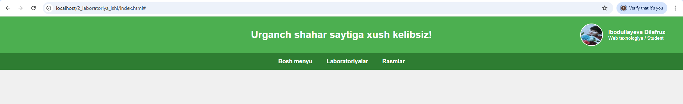
- qadam: Menyudan laboratoriyalarni tansalak,1,2 va hokaza laboratoriytalar va topshiriqlar natijasi chiqadi:
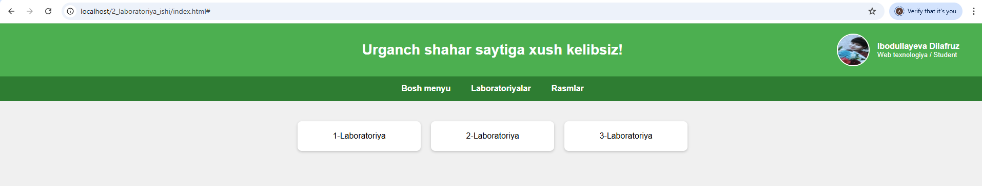
- qadam: 2-laboratoriyaning natijasi:
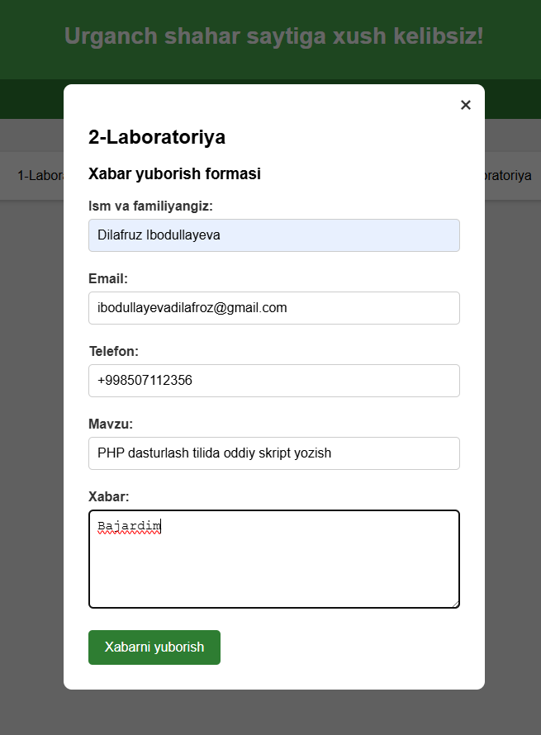
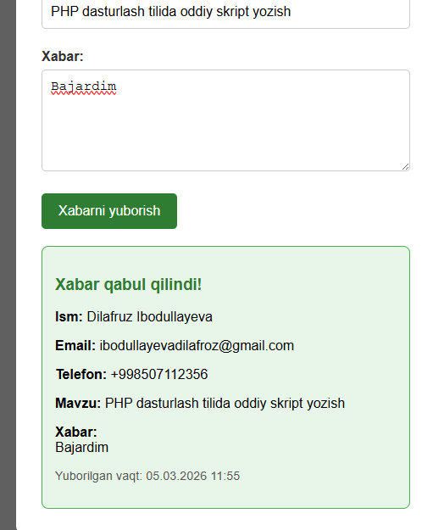
Xulosa
Ushbu laboratoriya ishi orqali PHP tilining asosiy mexanizmlarini (forma bilan integratsiya, superglobal o‘zgaruvchilar, ma’lumotlar xavfsizligi) amalda qo‘llashni o‘rgandim. HTML + CSS + JavaScript + PHP kombinatsiyasi yordamida oddiy, ammo funksional veb-ilova yaratish mumkinligini tajriba qildim.Kelajakda bu bilimlarni kengaytirib, ma’lumotlar bazasi (MySQL) bilan bog‘lash, email yuborish, validatsiya qilish (masalan email formati, telefon maskasi) va real loyihalarda (masalan, kontakt formasi, buyurtma shakli) qo‘llash mumkin bo‘ladi.Laboratoriya ishi muvaffaqiyatli yakunlandi. PHP va veb-dasturlashning asosiy tamoyillarini amalda mustahkamladim.

